**Pixel Editor**

A Mini Project Report Submitted by

Rahul D Shetty 4NM16CS111

UNDER THE GUIDANCE OF

**Dr. Aravinda C V**

Assisstant Professor Gd III

Department of Computer Science and Engineering

in partial fulfilment of the requirements for the award of the Degree

of

Bachelor of Engineering in Computer Science and Engineering

from

Visvesvaraya Technological University, Belgaum



(ISO 9001:2015 Certified), Accredited with ‘A’ Grade by NAAC

: 08258 - 281039 – 281263, Fax: 08258 – 281265

**Department of Computer Science and Engineering**

B.E. CSE Program Accredited by NBA, New Delhi from 1-7-2018 to 30-6-2021

April 2018



(ISO 9001:2015 Certified), Accredited with ‘A’ Grade by NAAC

: 08258 - 281039 – 281263, Fax: 08258 – 281265

**Department of Computer Science and Engineering**

B.E. CSE Program Accredited by NBA, New Delhi from 1-7-2018 to 30-6-2021

**Department of Computer Science and Engineering**

CERTIFICATE

*Certified that the mini project entitled*

***Pixel Editor***

*is a bona fide work carried out by*

***Rahul D Shetty (4NM16CS111)***

*in partial fulfilment of the requirements for the award of*

***Bachelor of Engineering Degree in Computer Science and Engineering***

*prescribed by* ***Visvesvaraya Technological University, Belgaum***

*during the year 2018-2019.*

*It is certified that all corrections/suggestions indicated for Internal Assessment have been incorporated in the report.*

*The mini project report has been approved as it satisfies the academic requirements in respect of the project work prescribed for Bachelor of Engineering Degree.*

**Name & Signature of Guide Name & Signature of HOD**

Dr Aravinda C V Dr. K R Udaya Kumar Reddy

Assistant Professor Gd III Head of the Department

Department of CSE Department of CSE

NMAMIT, NITTE NMAMIT, NITTE

# **ACKNOWLEDGEMENT**

We believe that our project will be complete only after we thank the people who have contributed to make this project successful.

First and foremost, our sincere thanks to our beloved principal, **Dr. Niranjan N. Chiplunkar** for giving us an opportunity to carry out our project work at our college and providing us with all the needed facilities.

We express our deep sense of gratitude and indebtedness to our guide **Dr. Aravinda C V**, Assistant Professor Gd III, Department of Computer Science and Engineering, for his inspiring guidance, constant encouragement, support and suggestions for improvement during the course of our project.

We sincerely thank **Dr. K.R. Udaya Kumar Reddy**, Head of Department of Computer Science and Engineering, Nitte Mahalinga Adyantaya Memorial Institute of Technology, Nitte.

We also thank all those who have supported us throughout the entire duration of our project.

Finally, we thank the staff members of the Department of Computer Science and Engineering and all our friends for their honest opinions and suggestions throughout the course of our project.

Rahul D Shetty (4NM16CS111)

**ABSTRACT**

Nowadays “Image Processing” is normally used by wide range of applications and in different types of electronics like computers, digital cameras, mobile phones etc. The image properties can be changed with the least investment such as contrast enhancement, borders detection, intensity measurement and apply different mathematical functions to enhance the imagery. Even though these methods with dump, but understanding the fundamental values behind the effortless image processing routine is rare. The method of image processing is used to do some processes on a picture like an image enhancement or to remove some functional data from the image.

Image processing is one kind of signal processing, where the input is a picture, as well as the output, are feature or characteristics allied with the image. The goal of this project is to build a multipurpose image editing tool which contains all the important image enhancement, morphological operations. The tool is mainly focused on faster image processing by making use of latest technological features provided by the programming language C#. All the processing code is designed from scratch and in order for faster calculation of the convolution operations, a special code segment in C# called *unsafe* is used.

There are many modern-day tools available in market which does most of the operations that is included in this project, but most of them require a high demanding PC specification and use up the most of the memory while being executed. This application focuses to provide all the high level or complex operations at a real low cost in terms of space and time. The project makes use of various morphological transformations, image enhancement techniques, various filtering options, thresholding and much more.

These operations are the basic for various image processing applications which is used in real time systems like CCTV face recognition where different noises can be reduced by applying particular filters. The project provides a way for users to switch between multiple images and work on them individually and independently.

**TABLE OF CONTENTS**

**Title Page**i

**Certificate**ii

**Acknowledgement**iii

**Abstract**iv

**Table of Contents**v

**List of Figures**vi

**List of Tables**viii

**1. Introduction**

1. Basics of Image Processing1

2. Image Representation2

3. Organization of Chapters3

**2. Problem Statement & Objectives**

1. Problem Statement5

2. Objectives5

3. Related Reading6

4. Existing Solution7

**3. Project**

1. Methodology

1. Convolution9

2. Gray Scaling11

3. Morphological Operation11

4. Transform Operation12

5. Histogram Equalization13

2. Pixel Editor 13

3. Implementation14

4. Results17

**4. Conclusion and Future Work**

1. Conclusion29

2. Future Work29

**5. References**31

**LIST OF FIGURES**

Figure 1.1: Different Fields of Image Processing1

Figure 1.2: Matrix Representation of Image2

Figure 1.3: Pixel Values2

Figure 1.4: Stages in Image Processing3

Figure 3.1: Applying Convolution6

Figure 3.2: Convolutional Processing7

Figure 3.3: Mathematical Outcomes8

Figure 3.4: Calculation of Gray scale given RGB values8

Figure 3.5: Image Dilation9

Figure 3.6: Image Erosion9

Figure 3.7: Algorithm for Histogram Equalization10

Figure 3.8: Program GUI11

Figure 3.9: General Structure of Code12

Figure 3.10: Original Image 118

Figure 3.11: Mean Blur18

Figure 3.12: Gaussian Blur19

Figure 3.13: Edge Enhancement19

Figure 3.14: Emboss Filter20

Figure 3.15: Image Inversion20

Figure 3.16: Blue Channel21

Figure 3.17: Green Channel21

Figure 3.18: Red Channel22

Figure 3.19: Original Image 222

Figure 3.20: Color Image Histogram Equalization23

Figure 3.21: Original Image 323

Figure 3.22: Dilation24

Figure 3.23: Erosion24

Figure 3.24: Perimeter Identification24

Figure 3.25: Program Example25

Figure 3.26: 90* Clockwise Rotation25

Figure 3.27: 90* Counter Clockwise Rotation25

Figure 3.28: Image Flipping Horizontal26

Figure 3.29: Image Flipping Vertical26

Figure 3.30: Original Image 427

Figure 3.31: Image Perimeter27

Figure 3.32: Image Closing28

Figure 3.33: Image Opening28

**LIST OF TABLES**

Table 3.1: Filter List 116

Table 3.2: Filter List 217

**Chapter 1**

**INTRODUCTION**

**1.1 Basics of Image Processing**

In computer science, DigitalImage Processing is the use of computer algorithms to perform image processing on digital images. As a popular subcategory of Digital Signal Processing, in Digital Image Processing has major advantages over Analog Image processing. It allows wide range of algorithms to be applied to the input data and avoid problems such as the build-up of noise and signal distortion during processing. Here we can make use of much complex algorithms and hence can offer both Sophisticated performance at simple tasks and implementations of methods which would be impossible by analog means.

Having said the above main features of using Digital Image Processing, the following project uses the same for all the mathematical computations on image. The main objective of this project is to build an easy to use Image editing tool for multipurpose applications. The application provides a basic layout to load and observe the changes that are performed on the image. Some of the key operations provided by the applications include Gray scaling, Image Blurring or Smoothening, Image Rotations and Flipping, Edge detection, Various Filtering Techniques, Histogram Equalization for both color and black/white images and morphological operations like Open, Close, Erosion and Dilation.

Most of the operations mentioned above involves simple and complex operations on image. For most of the filtering techniques, a Convolutions is used for processing the image pixel by pixel.

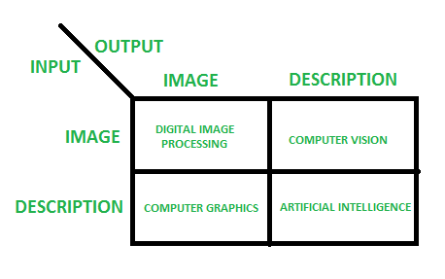

Figure 1.1: Different Fields of Image Processing

Figure 1.1 shows how we categorize the applications of image processing based on inputs and outputs. This projects solely focuses on the first part where both the input and outputs are images.

**1.2 Image Representation**

Pixel is the smallest element that can be represented on a computer monitor and each pixel or picture element consist of a value that represent the intensity at that point. A Digital Image is a two-dimensional arrangement of these pixels in tabular form where each and every point in the table represents the intensity of the pixels at that coordinates which will be similar to that of when represented in special coordinates. Since computer can only understand 0’s and 1’s, an image is stored in computers as matrix of these values ranging from 0 to 255 for each Red, Green and Blue color channel.

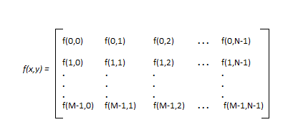

Figure 1.2: Matrix Representation of Image

Figure 1.2 shows how an image is represented in terms of a matrix of size M x N where it contains M rows and N columns. Each cell contains a value that ranges from 0 to 255. For Black and White images, there is only one-color channel that shows the intensity at each point while Color images are having the same but across Red (R), Green (G) and Blue (B) channels. The application is designed to work on both the image channels and get a proper output in terms of image again. Figure 1.3 shows how a 5 x 5 region of a larger image will contain different pixel values.

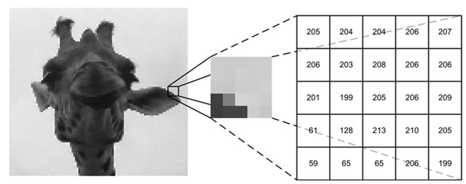

Figure 1.3: Pixel Values

The Figure 1.4 shows the basic steps involved in image processing. For the given project, we already have obtained a set of input images which are captured from image sensor devices and are stored digitally on a computer. Our program reads these images and work on the spatial domain for applying various filtering techniques, even uses Image Enhancement techniques and Color Image processing on different channels to provide an output image which is again a digital image.

The application works by operating on each pixel of the image and applying the appropriate filter or technique. Most of the operations involves using a window or kernel which needs to be moved around the entire picture pixel by pixel and then try to find the maximum, minimum, multiplying with the kernel or such of these operations are made based on type of feature we need to extract and store the value of that pixel in a new image at same location. At any time, users can work on multiple images at a time.

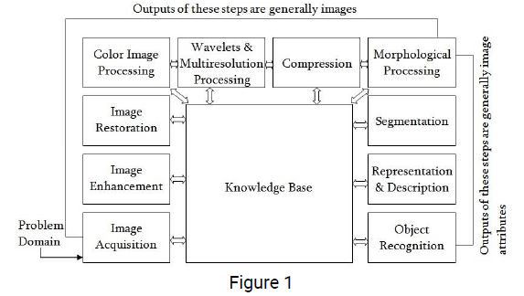

Figure 1.4: Stages in Image Processing

The implementation of the project is done by using C# and it is designed to support all systems with .NET framework 4.6 or above. Various filtering techniques have been incorporated, some morphological operations are added for obtaining results with shape, Histogram Equalization is provided and features of typical photo editing application are integrated.

**1.3 Organization of Chapters**

The mini project report has been organized under five chapters, which are as follows:

**Chapter 1:** Introduction about the subject topic.

**Chapter 2:** It includes details about the problem statements, objective and literature survey.

**Chapter 3:** The methodology used in this project, implementation and results of the project.

**Chapter 4:** Outlines the conclusion and future work.

**Chapter 5:** References used for this project.

**Chapter 2**

**PROBLEM STATEMENT AND OBJECTIVES**

**2.1 Problem Statement**

In the recent market there are various tools or applications that does most of the previously mentioned operations but most of these types of applications requires higher system configuration in terms of CPU, memory and space. And some of these applications even require special hardware like a graphical processing unit (GPU) for running it smoothly in the systems. This is a major drawback, as most systems still run on older CPU and do not use any GPU as they are expensive to purchase.

There are tools like MATLAB which performs even complex and custom operations on images. The only constraint here is that the user needs to know the programming language associated with this tool in order to perform any operations and this becomes cumbersome for majority of normal users. Also, the tools available demands a high storage space. This is another issue since space available in the system in limited and one cannot provide all the space for only one application.

Most users are in need of an application that does complex image operations in ease and gives them in understandable format. Also, these users do expect the output to be shown in reasonable amount of time. Hence there is a major issue with tradeoffs on all these factors like speed, memory usage, storage required and easy to use interface.

**2.2 Objectives**

The main objective or goals of this project is to overcome most of the problems stated earlier. Along with those, the application provides various operations more efficiently. Some of the operations that were the primary goals of this are stated below:

1. Converting an RGB color image to a gray scale image.
2. Filtering techniques to provide image smoothening.
3. Filtering techniques to identify edges in a given image.
4. Histogram Balancing or Equalization for both Color and gray scale Images.
5. Image flipping (Horizontal and Vertical).
6. Image Rotation (Clockwise and Anti-Clockwise).
7. Loading Multiple Images at a time.
8. Saving changes to the images.
9. Undo any operation performed on the image.
10. Brightness and Contrast adjustments.
11. Morphological Operations like Erosion, Dilation, Open and Close.
12. Faster convolutional processing.
13. Image Enhancements with various filters.

**2.3 Related Readings**

The objectives provided by this application is based on result of research works done by various people. Consider the basic process of converting a color image from RGB to gray scale, this can be achieved by various formulas or techniques. The most popular method to achieve this is stated by CIE 1931 color space [1] which were the first one to define quantitative link between distributions of various wavelengths in electromagnetic visible spectrum and psychologically perceived colors in human color visions. This was created by International Commission on Illumination in 1931. This was resulted due to the series of experiments done by William David Wright and John Guild. This was later presented to be the specification of the CIE RGB color space, from which CIE XYZ [1] color space was derived. Gray scaling is done based on the results of this experiment.

The kernels or masks are the simplest and powerful methods used for image processing. Here we move a mask of some window size across the entire image to obtain a resultant based on weights of each pixels in the mask. The basics of this technique is derived from a field of mathematics called Mathematical Convolution [2]. Basically, here we present an operator on two functions *f* and *g* to produce a third function that expresses how the shape of one is modified by the other. In our case *f* represents the image and *g* is the kernel mask that is used to produce resultant image. Just by varying the weights in *g* we can obtain different results. Image smoothening, edge enhancement and additional effects can be done on an image using this technique.

Histogram describes about how many pixels have occurred how many times. Histogram Equalization is used to increase the contrast of the image by equalizing the distribution of histogram. This technique is used as preprocessing in various application due to its simplicity and the contrast effect on the resultant image. The procedure used in this involves normalizing the distribution and later trying to balance this. Then we use the latest balanced information to set the pixel values for the contrast enhanced image. This was the result of research work written by Ruye Wang [3].

Image rotation is a popular transformation technique used to orient the image as we require. Mathematically it involves multiplying with a matrix which orients each pixel to a new location. The popular work written by D. Ballard and C. Brown [4] specifies how we can use a general formula to achieve this. In the given project we used this method to achieve image transformation based on Clockwise and Anti-Clockwise 90* rotation, Flipping the image to get a mirror effect across X and Y axis of the image. Further we can generalize it to translate it across any direction and angle.

The application provides an option to control the contrast and brightness of the image. Brightness refers to the amount of lightness present in the image. In HSL color space the L value represents the brightness of the image. Therefore, according to the work written by Charles Poynton [5] the brightness can be adjusted by adding in more details for a particular pixel across different channels. Contrast adjustments involves making light pixels lighter and dark pixels even darker.

Morphological operations on images is based on from a work written by Robert Fisher, Simon Perkins, Ashley Walker and Erik Wolfart [6] in their reference Hypermedia Image Processing Reference. All the operations implemented like Open, Close, Erosion and Dilation are defined as per the reference.

**2.4 Existing Solution**

This project focuses on achieving all the objects as defined earlier in terms of an easy to use application tool for the end users. But in the market, there are couple of software tools which provides the same. The most popular among these tools include Adobe Photoshop, GIMP and MATLAB. Some of the programming languages provide additional libraries for image processing like OpenCV is an open source library which provides features similar to MATLAB but for various programming languages.

Adobe Photoshop is a popular tool available in the market which is used by various designers across the globe. The application provides all the features for processing along with which it provides users to work on raster graphics. But one of the drawbacks in this tool is that it needs a good system configuration in order to run this tool. So, an end user with poor performance system could not use it effectively. And this tool also provides a faster processing if there is a GPU present in the system. Again, a GPU would be expensive to buy and has limited usage in daily works. This makes the tool resource demanding.

Another popular tool which is similar to Photoshop is GIMP. This is an open source tool available for everyone. This is also a cross platform tool. Unlike Photoshop the requirements of this application are less as it doesn’t require much resources. But the features it provides and the UI is something that would be hard for a normal user to work with. This is one of the drawbacks of using this tool.

MATLAB is a professional tool for research and programmers for developing applications. This provides a programming language platform where the user has to code the operation they want or call in the method or function that’s already defined. The major disadvantage is that a normal user usually wants to use some simple features and won’t be having the prior programming knowledge. This makes it difficult for them to use. Also, the hardware requirements are not simple one. It requires a high-end system to work efficiently.

The major part of this project is to provide a simple, easy to use software with less requirements in terms of CPU, memory and other hardware components. Also, the users should be able to freely do any operation they want on images and produce a reasonable result with a good throughput. The application supports windows platform with .NET framework and can be executed in Linux system using Mono architecture which executes these .NET applications but in Linux.

**Chapter 3**

**PROJECT**

**3.1 Methodology**

**3.1.1 Convolution**

The major part of the project is applying the convolution across the entire image and obtain the result in terms of an image. In order to apply this, we need to traverse each and every pixel and also at each level of the pixel we need to identify all the 8 neighbor pixels in order to apply the given kernel. There are various algorithms involved in doing this operation, but for this project the basic strategy of taking two loops to traverse each and every element in the given image and applying the convolution by going across the window of that kernel.

Figure 3.1 represents the operation of applying the filter across a 3 x 3 region of the first 3 rows and first 3 columns. Based on application we can apply different kernel to obtain different outcomes. In the below figure an Emboss filter for image enhancement is used. Every filter has their own weights associated with them which are important for finding the new value of the pixel at a location. In the below example the weights associated are +4 and -4 across the end diagonals. Most kernels have equal weights of positive and negative value which on added generates a sum 0. This is done to average the overall effect on applying the kernel.

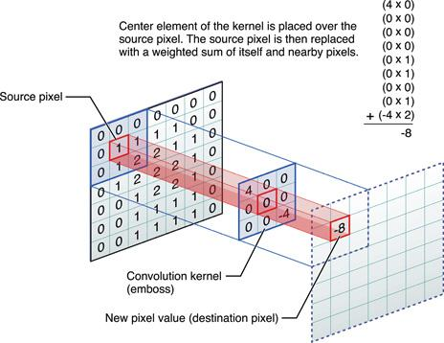

Figure 3.1: Applying Convolution

A kernel or Mask is a filter which are used for spatial filtering. There are different types of these filters, but majorly they are categorized as Linear and Frequency Domain Filters. Based on purpose usually filters are applied in order to do either blurring or smoothening otherwise for finding or enhancing the edges. Blurring cancels out all the noise present in the image which is a major part in many Image Application Domain while Edge detection is used for Object Recognition similar applications.

In order to perform any convolution general logic used is:

* Append additional 0’s or padding to the given image.
* Flip the mask (horizontally and vertically) only once
* Slide the mask onto the image.
* Multiply the corresponding elements and then add them
* Repeat this procedure until all values of the image has been calculated.

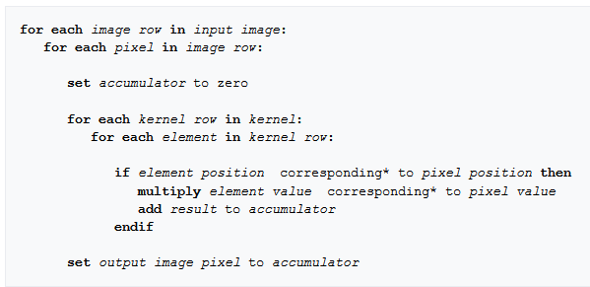

Figure 3.2: Convolutional Processing

Figure 3.2 shows the pseudo code in order to apply the kernel of some size to our image. There are 5 schemes used to handle convolutions involving edge pixels.

Extend:

The nearest border pixels are conceptually extended as far as necessary to provide values for the convolution. Corner pixels are extended in 90° wedges. Other edge pixels are extended in lines.

Wrap:

The image is conceptually wrapped (or tiled) and values are taken from the opposite edge or corner.

Mirror:

The image is conceptually mirrored at the edges. For example, attempting to read a pixel 3 units outside an edge reads one 3 units inside the edge instead.

Crop:

Any pixel in the output image which would require values from beyond the edge is skipped. This method can result in the output image being slightly smaller, with the edges having been cropped.

Kernel Crop:

Any pixel in the kernel that extends past the input image isn't used and the normalizing is adjusted to compensate.



Figure 3.3: Mathematical Outcomes

In Figure 6 there is a pixel values represented by alphabets and kernel is shown by digits. According to the algorithm the resultant pixel value is computed as shown in Figure 3.3. All the filter techniques use the same principal but with different values of kernel in order to get a particular result.

**3.1.2 Gray Scaling**

Additional features included in this application is gray scaling which is to convert a color image to a black and white image. There are various techniques to perform this operation which may include applying a formula or by applying a mask. The given program uses the mathematical approach to find the value of the newer pixels.

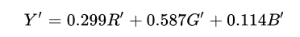

Figure 3.4: Calculation of Gray scale given RGB values

In order to perform gray scaling following logic is used:

* Create a new temporary result matrix of same size as the image.
* Traverse across each pixel one by one.
* Obtain R’, G’, B’ values which correspond to Red, Green and Blue pixel value at that pixel point.
* Apply the formula in Figure 3.4 to find Y’ which is the required output and fill it into the new matrix.
* Repeat the above 4 steps until no more pixels can be traversed.

In most applications gray scaling provides an efficient way to perform various tasks and then map the result back to color images. Gray scale image processing is faster when compared to color images as we only have 1 channel in a gray scale image. For a black and white image each pixel represents the intensity of the light at that position in spatial domain.

**3.1.3 Morphological Operations**

Here we try to apply a structuring element to an image in order to obtain a particular result. Each of these structuring elements is similar to that of kernel but under this we do some mathematical operation such as XOR, BITWISE_OR, AND, OR and finding the minimum or maximum elements in the window.

Dilation:

The value of the output pixel is the maximum value of all pixels in the neighbourhood. In a binary image, a pixel is set to 1 if any of the neighbouring pixels have the value 1. Morphological dilation makes objects more visible and fills in small holes in objects. Figure 3.5 below shows this operation.

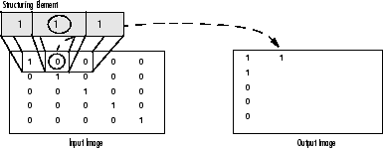

Figure 3.5: Image Dilation

Erosion:

The value of the output pixel is the *minimum* value of all pixels in the neighbourhood. In a binary image, a pixel is set to 0 if any of the neighbouring pixels have the value 0. Morphological erosion removes islands and small objects so that only substantive objects remain. This is shown in the Figure 3.6.

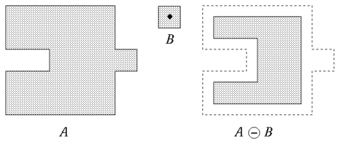

Figure 3.6: Image Erosion

Open:

The operation of erosion followed by dilation using some specified structuring elements is known as Open operation.

Close:

The operation of dilation followed by erosion using some specified structuring elements is known as Open operation.

**3.1.4 Transform Operation**

Image transforms are used to change the orientation or for finding the mirror images across some axis. Rotation and Flipping are the two most operations used in this technique. Rotations involves changing the image by rotating it in clockwise or anti-clockwise direction. These operations involve transposing the matrix to change from M x N to N x M order. Flipping is another transform operation where we take the mirror image across X or Y axis. All these operations involve accessing each pixel and then positioning them accordingly.

**3.1.5 Histogram Equalization**

Histogram equalization is a technique for adjusting image intensities to enhance contrast. This method usually increases the global contrast of many images, especially when the usable data of the image is represented by close contrast values. Through this adjustment, the intensities can be better distributed on the histogram. This allows for areas of lower local contrast to gain a higher contrast. Histogram equalization accomplishes this by effectively spreading out the most frequent intensity values.

The method is useful in images with backgrounds and foregrounds that are both bright or both dark. In particular, the method can lead to better views of bone structure in x-ray images, and to better detail in photographs that are over or under-exposed. A key advantage of the method is that it is a fairly straightforward technique and an invertible operator. So in theory, if the histogram equalization function is known, then the original histogram can be recovered. The calculation is not computationally intensive. A disadvantage of the method is that it is indiscriminate. It may increase the contrast of background noise, while decreasing the usable signal.

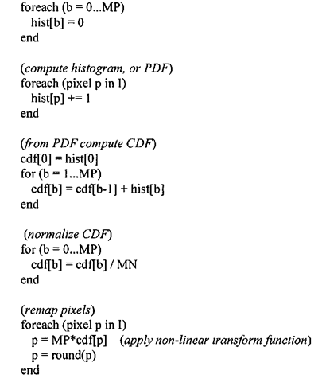

Figure 3.7: Algorithm for Histogram Equalization

Figure 3.7 shows the algorithm used for computing the new pixel values after evening out the original distribution. For black and white images, it is straightforward to apply this to one of the channels but for color images different methods are considered. In our application we apply equalization over all the 3 channels and then combine to get the final result.

**3.2 Pixel Editor**

Pixel Editor is a multipurpose image processing tool for Windows platform. It is designed in such a way that to provide processing of higher or complex convolutional operations on any image at faster rate and making efficient use of available resources. Pixel Editor provides users with easy to use and neat Graphical User Interface designed by using Metro Theme.

This application provides users with various operations like gray scaling, image smoothening using different types of filters, edge detection based on filters, image flipping and rotating operations, morphological operations like closing, opening, erosion and dilation. A histogram is shown for different color channels individually and we can perform Equalization of these using this application.

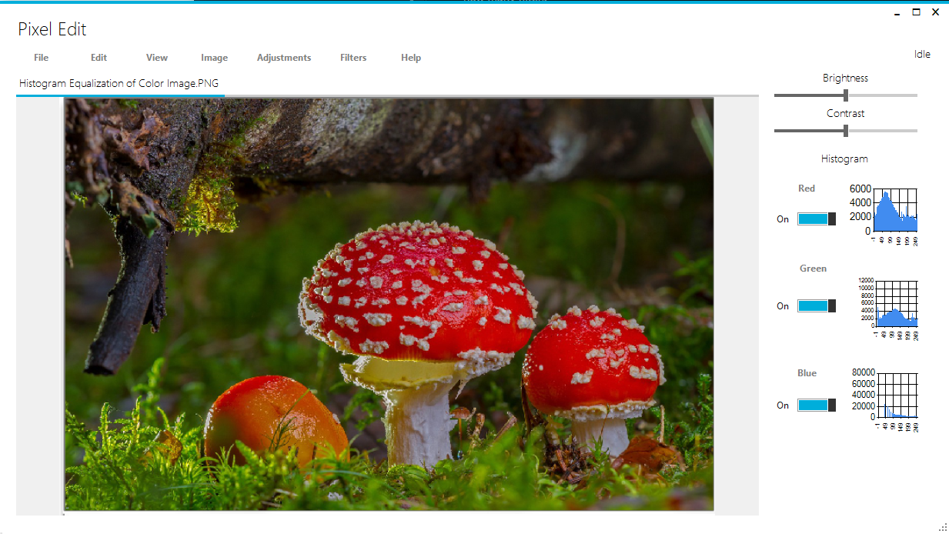

Figure 3.8: Program GUI

Figure 3.8 shows the overall look of the final application. The above UI is designed based on Metro UI theming concepts to make it easy for end users to operate. Various image processing features are available from different Menu’s provided in the application.

Pixel Editor also allows users to open up multiple images and work on them independently and switch between them at any time. All the operations are saved in stack so that the users can go back to previous state of the image if any wrong operation was performed. This makes it easier for users to work with the image.

**3.3 Implementation**

The entire source code is designed in C# programming language. This language was preferred because of its easy to use GUI editing toolkit. The Metro UI in Figure 11 uses Metro Mash Theme. The application is a Windows Form application which can be executed on all Windows system that support .NET Frameworks 4.6 and above. All the components used are provided by the Metro Mash and Windows Toolbox.

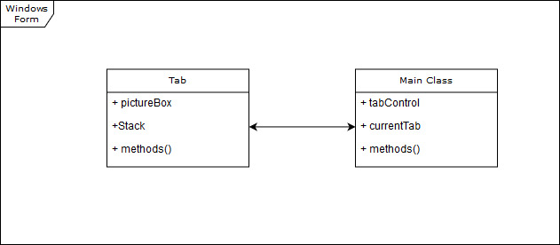

Figure 5.9: General Structure of Code

Figure 3.9 shows how the entire code is divided as. Basically we have 2 prime modules, Main and Tab. Main class controls how the entire windows form looks like and we define events under this class. Primarily this class form contains a Tab Control Layout which is used for providing the users with loading multiple images and working on them independently. The class contains an insert Tab method which is used to create a new Tab and add it to the list. Each Tab when created includes various variables and methods, out of which pictureBox element is used to display the image onto the screen.

C# uses Object Oriented Programming concepts which helps us in reusing the already written code. Creation of GUI from scratch is easy and fast when compared to doing it by coding each components. Each element in the GUI contains properties which are values associated with them and event which can be overridden to do something when that occurs.

All the methods are defined in general way to access the methods at any time. Each Tab maintains a stack which is used for saving the state of images just before the edit. This is used in order to revert back the changes thereby undoing any operation which was done on the image. All the operations on the image is done by loading the image into Bitmap Object and then accessing the elements from them.

In order to apply different kernel to the image, a general method is written called as *applyKernel()* which takes in the kernel information as input and produces a Bitmap object. After Locking the image, we can read it in terms of bytes by various methods and then apply the kernel to each pixel one by one. Kernel is a 2D matrix that represents the same in frequency domain.

All the pixel accessing operations use the same strategy of locking and unlocking the images before editing for faster execution. For Histogram Equalization we first perform this operation based on the color scheme that is selected. Then by using Chart Element from Windows Form GUI Toolkit we then represent the values of pixel distribution on to this chartElement and present it to the user. Figure 3.8 shows a typical RGB histogram for that particular image.

All the operation on the image is performed as per the algorithms mentioned in the previous Methodology Section. Some of the kernels used in this program includes from blurring techniques to edge detection. Some of these are shown in Table 3.1 and Table 3.2.

|  |  |
| --- | --- |
| Kernel | Operation |
|  | Simple Mean Blur |
|  | Edge Detection Filter |
|  | Emboss |
|  | Gaussian Filter |
|  | Laplacian Filter |
|  | Laplacian of Gaussian |

Table 3.1: Filter List 1

|  |  |
| --- | --- |
| Kernel | Operation |
|  | Laplacian of Gaussian |
|  | Prewitt Operator |
|  | Sharpening Filter |
|  | Sobel Horizontal Operator |
|  | Sobel Vertical Operator |

Table 3.2: Filter List 2

In the above Table 3.1 and Table 3.2 we can notice various filters used by the program to do the operations defined along with them. We create a 2-dimensional array of these integers and pass them to *applyFilter* method to apply this to our image. Every time the tab that is selected is used for image processing.

**3.4 Result**

This section covers the output of our program for different operations. Figure 3.10 is used as a sample data for different operations. Each Figure captions describe the various operations. The operations on image is done by calling the method *applyKernel()* over the different filters shown in the previous table.

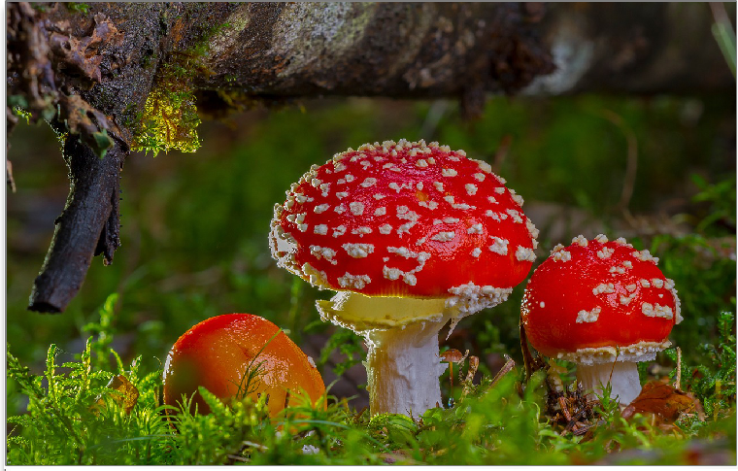

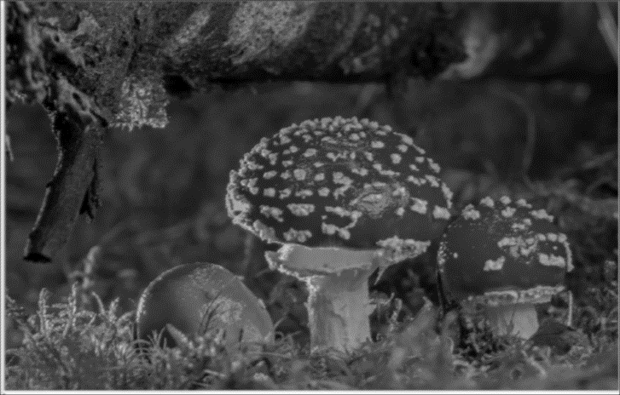Figure 3.10: Original Image 1

Figure 3.11: Mean Blur

Figure 3.10 is the original image that is taken as a reference for performing various operations. Figure 3.11 shows the output of performing mean blur which is performed using the Simple Mean Filter shown in Table 3.1. We pass in the filter information to our *applyKernel* method and obtain the result.

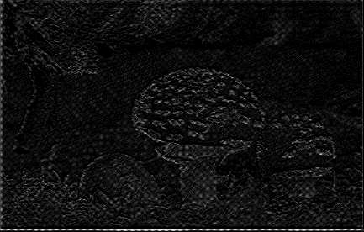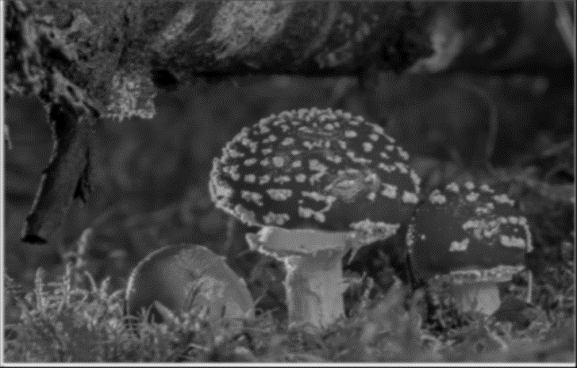

Figure 3.12: Gaussian Blur

Figure 3.13: Edge enhancement

Figure 3.12 shows the output of the image when we apply the Gaussian Blue filter mentioned in Table 3.1 on the original image of Figure 3.10. When compared to the normal mean the noises are reduced more effectively and edges are more smoothened out. In Figure 3.13, a medium level Edge enhancement technique is used in order to obtain the above results.

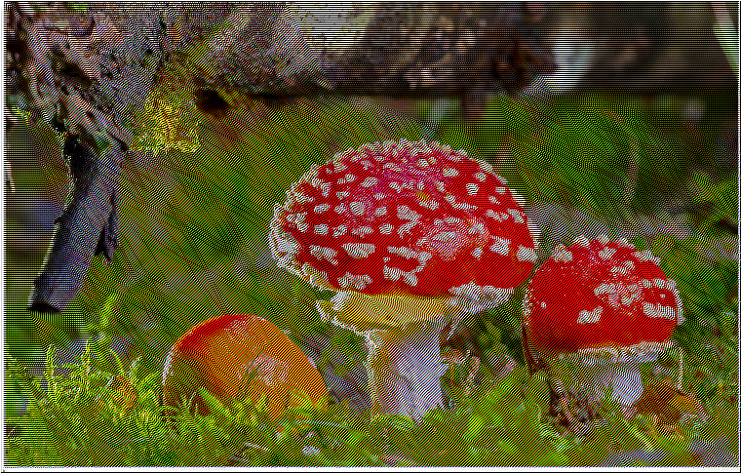

Figure 3.14: Emboss Filter

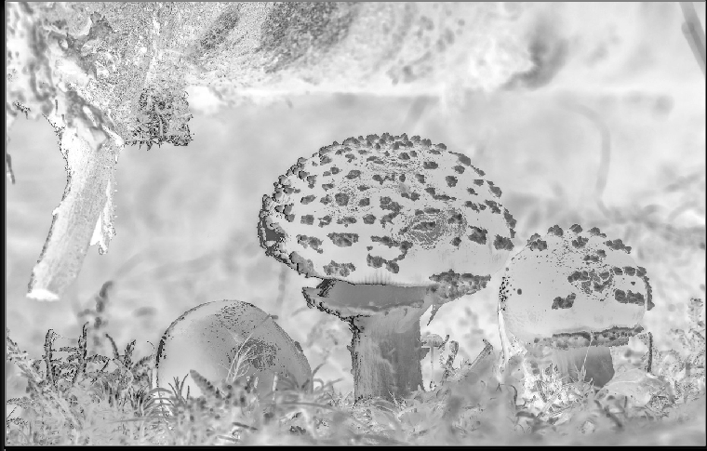

Figure 3.15: Image Inversion

Figure 3.14 is the result of applying Emboss filter that is mentioned in Table 3.1 to the Figure 3.10 of our original Image. The filter provides a vivid effect on color images while a noticeable change in gray scale images. Another simple operation on image is taking the negative of image. This was used to store images in films in olden times where an image would be imprinted in negative form in the film reel. Figure 3.15 shows the negative of the original image shown in Figure 3.10 which is obtained by subtracting each pixel value with 255.

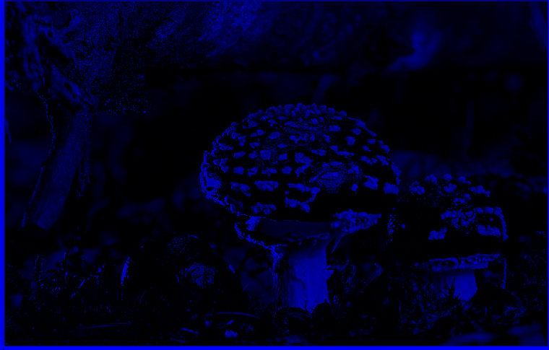

Figure 3.16: Blue Channel

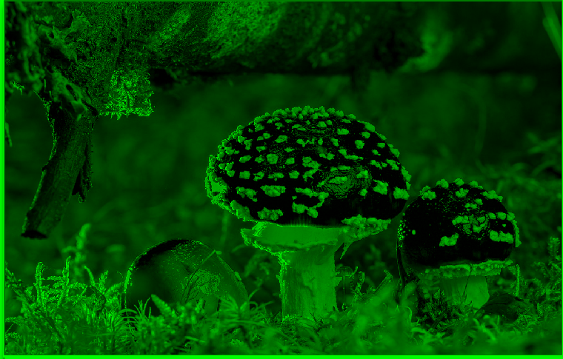

Figure 3.17: Green Channel

Figure 3.16 represents the Blue Channel of the original image shown in Figure 3.10. Similarly Figure 3.17 shows the Green Channel of the same image. In different application we need to use different types of images based on colors, intensities, brightness and so on. Clearly we can notice how the original image in blue color contains less features when compared to the green, which shows most of the features. This is due to the reason that our original image in Figure 3.10 contains majority of green components and therefore it is highlighted more in its corresponding channels.

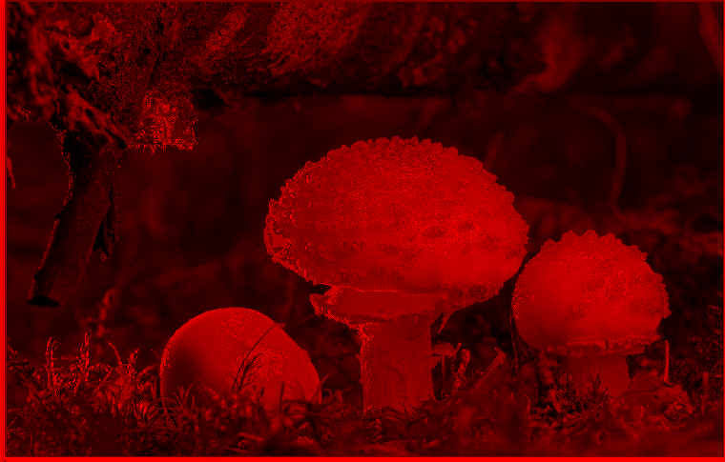

Figure 6.18: Red Channel

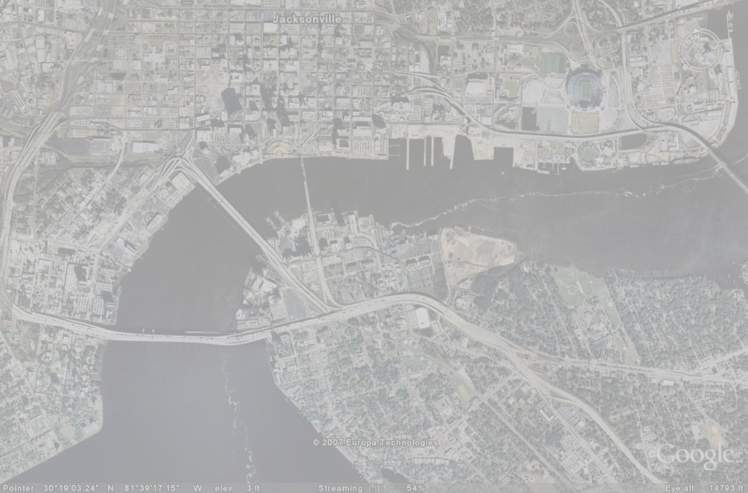

Figure 3.19: Original Image 2

Figure 3.18 shows the Red channel component of the original image shown in Figure 3.10. All of the different channels of the images are obtained by setting the pixel values of remaining components as zero. For example, in order to obtain the red channel as shown in Figure 3.18 the operations include accessing each pixels from the image in Figure 3.10 and storing the following information into the new image ‘(r,0,0)’. The ‘r’ components represents the value of red pixel at a particular location and 0 are used to set the values of green and blue pixel values. This way only the red components is highlighted in the entire image.

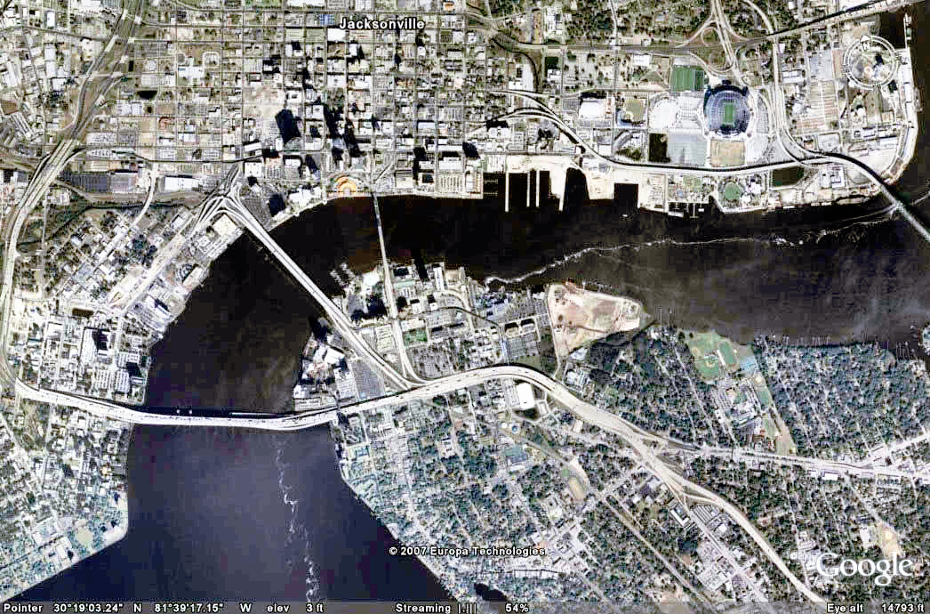

Figure 3.20: Color Image Histogram Equalization

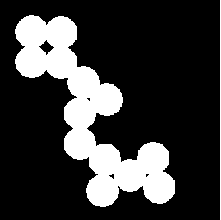

Figure 3.21: Original Image 3

Figure 3.19 is now used as another reference image for performing the Histogram Balancing operation. This technique balances out the abnormal distribution of various pixel frequencies into a uniform distribution based on cumulative frequencies. There are various ways to achieve this but in the program, there are two implementations of this concept. In the first scenario we applied Histogram Equalization over Blue channel as it represents the most contrast in an image. In the second case we applied the same technique across all the channels and then we combined this channels together. The output of applying Histogram Equalization on Original Image in Figure 3.19 is shown in Figure 3.20.

Morphological operations are another set of techniques used to obtain a result for a particular region of interest based on the shape, color of the image in that area. Figure 3.22 shows the dilation operation performed on the original image in Figure 3.21 similarly Figure 3.23 is the Erosion operation performed on the same.

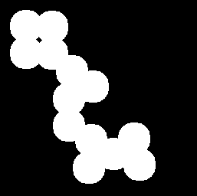

Figure 3.22: Dilation

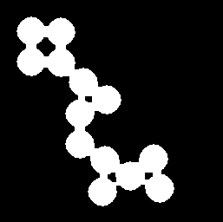

Figure 3.23: Erosion

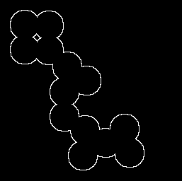

Figure 3.24: Perimeter Identification

Figure 3.24 is a Perimeter Identification operation which is an image border extraction technique implemented by XORing the results of Opening of the original image shown in Figure 3.21. This operation is more preferred when compared to the traditional edge enhancement technique using filters where results produced are noisy.

Figure 3.25 shows a demo of application where the image shown in Figure 3.10 is loaded. On the right hand side of the application there are 3 charts where each of them represents RGB.



Figure 3.25: Program Example

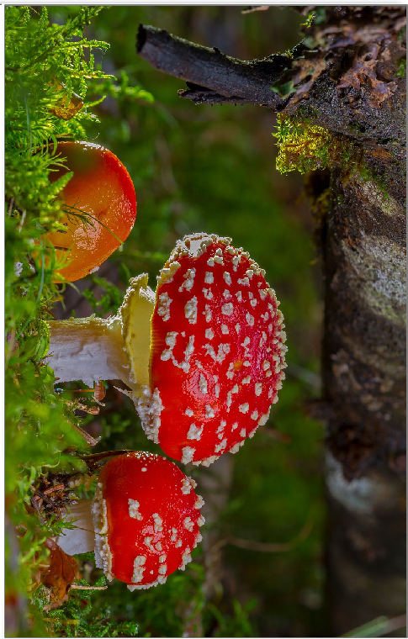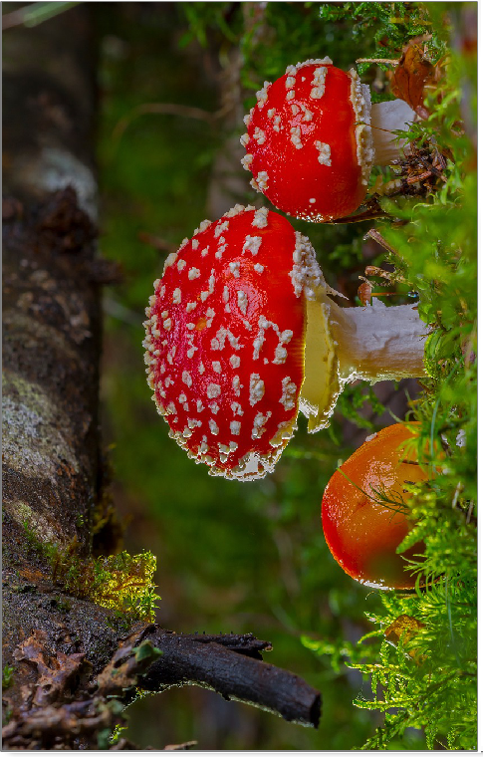

Figure 3.27: 90* Counter Clockwise Rotation

Figure 3.26: 90* Clockwise Rotation

Figure 3.26 and 3.27 shows clockwise and counter-clockwise 90* rotation of the original image. In both cases we transpose the given image to swap its original width and height. Then we copy the pixels to a particular new location as needed. This is simple operation that is achieved with loops and accessing (i,j) pixel and copying it to new location.

Figure 31 and 32 shows the mirror flipping results. In both cases the image size of the original and modified remain the same. Here we try to move the pixel at (i,j) to a new location based on width and height differences. This is again a simple operation which just involves moving the pixels to a new location and not performing any operation on them.

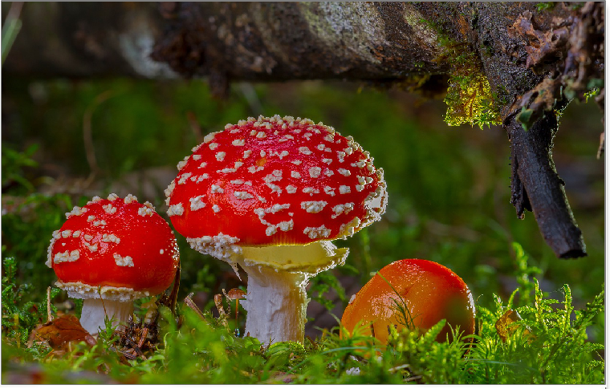

Figure 3.28: Image Flipping Horizontal

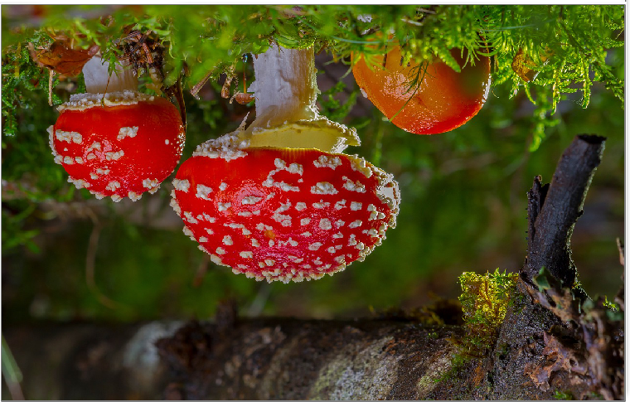

Figure 7: Image Flipping Vertical

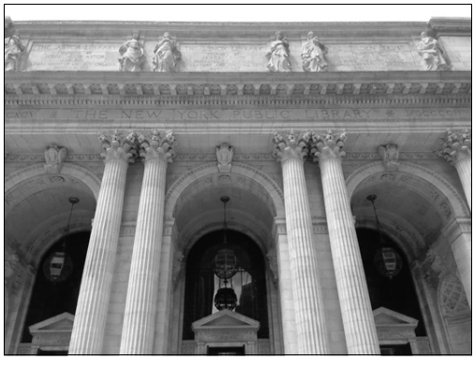

Figure 3.30: Original Image 4

Figure 3.30 represents a reference image over which we perform the open and close operation. After applying the perimeter operation on this image we obtain the following image as shown in Figure 3.31. This operation is the same one as mentioned before which is shown in the Figure 3.24.

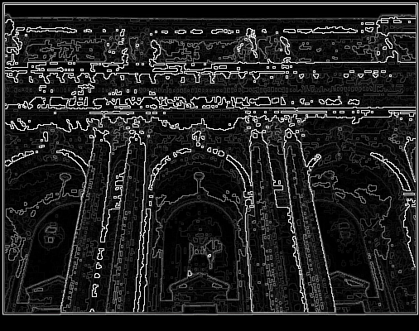

Figure 8.31: Image Perimeter

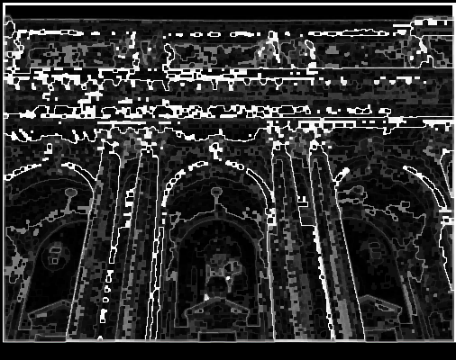

Figure 3.32: Image Closing

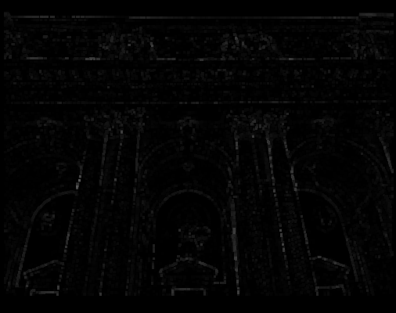

Figure 9: Image Opening

The image shown in Figure 3.31 is taken as reference image for performing close and open operations. These operations involve sequences of Erosion/Dilation or Dilation/Erosion. This is achieved manually by selecting which structure element to use or just by selection this option. Figure 3.32 shows the Image Closing operation on the reference image while the Figure 3.33 shows the Image Opening operation on the same reference image.

**Chapter 4**

**CONCLUSION AND FUTURE WORK**

**4.1 Conclusion**

The overall goal of the project was to design a user-friendly multi-purpose application for image processing. The users are given an option to load in multiple images from the directory and work on them independently. The project focuses on implementing Convolution Operation technique to apply different filters for different applications. Along with this some set of morphological operations are provided by the application which includes Erosion, Dilation, Open and Close.

The given application can work in any systems running on Windows Operating System and has .NET Frameworks (Version 4.6 or above) installed. An average configuration is sufficient to run this application without any issues. The designed application meets all the basic requirements as per the problem statement and objective.

**4.2 Future Work**

There is definitely scope for further improvements to this application in terms of Design, Code, Features and so on. Complex operations could be included to improve the software in terms of features. Better logic can be applied to improve the performance of the application. Layering ability can be added to work with different layers of images at a time. A feature for operating multiple functions on a batch on image can be provided where we need to perform same operation on different images for preprocessing. Concepts of Raster image processing can be incorporated for better image editing. Application can be made to run some operations on GPU which in turn will reduce the load on CPU and produce a better throughput.

**Chapter 5**

**REFERENCES**

|  |  |
| --- | --- |
| [1] | "Wikipedia," [Online]. Available: https://en.wikipedia.org/wiki/CIE_1931_color_space. |
| [2] | "Wikipedia," [Online]. Available: https://en.wikipedia.org/wiki/Kernel_(image_processing). |
| [3] | Ryue Wang, "Histogram Specification," 29 09 2016. [Online]. Available: http://fourier.eng.hmc.edu/e161/lectures/contrast_transform/node3.html. |
| [4] | D. Ballard & C. Brown, Computer Vision, Prentice Hall, 1982. |
| [5] | C. Poynton, "Brightness and Contrast controls," 2002. |
| [6] | A.Walker, R. Fisher, S.Perkins & E. Wolfart "Hypermedia Image Processing," 2003. |